HANDS-ON EXERCISE
Insurance Ontology Baseline
Week 1 · Day 3 · Self-Paced Lab, Fully Self-Contained · Prepared by Rajesh Pasham

Before You Begin
This is a self-paced lab, and it is fully self-contained: everything you need — including your reference data for all seven Object Types — is provided with this document. You do not need any file from the trainer beyond what's already attached, and you do not need a second account or a shared Project.
This Is Your First Hands-On Lab
Day 1 and Day 2 were theory sessions only — concepts and architecture, no live platform work. Nothing in this document assumes you've clicked through Foundry before. Every workflow below — creating a dataset, building a pipeline, creating an Object Type, applying security — is explained here for the first time, even where it builds on a concept Day 1 or Day 2 introduced in the lecture.
How Long This Takes
Budget 3–4 hours of focused work. This is longer than a typical Day 3 lab because it covers the full “Insurance Ontology Baseline” specification in one session, at production-realistic data volume — all seven Object Types backed by real data, none manually typed in. If you don't finish everything today, that's expected — see “If You Run Out of Time” at the end of this document.
You Are Working Entirely Solo
Every part of this lab, including the access-control test in Part 8, is designed around a single individual Developer Tier account with no shared Project, no batch-mate, and no second user. Where the underlying platform concept would normally involve another person, this lab shows you how to validate the same mechanism using only your own account.
What You Need Before Starting
- Your individual Palantir Developer Tier account, already signed in
- A Project of your own to work in — create one now if you haven't already
- The seven attached reference CSV files (policyholders.csv, policies.csv, claims.csv, payments.csv, adjusters.csv, investigations.csv, claim_documents.csv) — or the generation script in Part 1 if you'd rather produce them yourself
- Day 1 and Day 2 study guides open for reference — this lab assumes that material, it doesn't repeat it
Getting Unstuck Without the Trainer
- Re-read the relevant step first — most issues are a missed sub-step, not a platform problem
- Check the Troubleshooting appendix at the end of this document for the specific symptom you're seeing
- Search the exact error message in the Palantir Developer Community (community.palantir.com) — most Developer Tier issues have already been asked about
- Note the blocker in your validation checklist and bring it to Day 4 — a documented blocker is a legitimate outcome of a self-paced lab

Lab Outcome
By the end of this lab, you will have: a secured, agent-ready Insurance Ontology — all seven Object Types backed by real data, not one manually typed row — and a production-oriented, incremental pipeline baseline, built entirely within your own individual account.

Lab Roadmap
Part | Task
1 | Load your reference data — all seven datasets (300 rows each for the first four, plus 20 Adjusters, 60 Investigations, 586 Claim Documents)
2 | Build an incremental claims-transformation pipeline
3 | Configure schema and data-quality checks
4 | Implement branching and controlled promotion
5 | Create the seven Ontology objects, every one backed by real data
6 | Define complex object relationships
7 | Apply RBAC and ABAC controls
8 | Test restricted access to high-value and sensitive claims — solo method
9 | Review lineage and downstream dependencies

Part 1 — Load Your Reference Data
The curriculum assumes “preconfigured policy, customer, claim and payment data.” This lab extends that to all seven Object Types: Adjuster, Investigation, and Claim Document are backed by real, generated data too — not created empty and populated by hand. You do not need to type or paste this data.

Dataset Summary
All seven files use a fixed random seed, so this exact data is what both the attached files and Method B's script below produce — every number in this document is accurate for your dataset.
Dataset | Rows | Notable Characteristics
policyholders.csv | 300 | Unique policyholderId PH001–PH300
policies.csv | 300 | Unique policyId POL001–POL300; each references a valid policyholderId
claims.csv | 300 | 6 rows have an empty policyId (data-quality test target). 34 rows have claimAmount above 25,000 (high-value security test target). Every row includes an assignedAdjusterId
payments.csv | 300 | Every claimId references an Approved claim; 63 payments have paymentStatus of Pending
adjusters.csv | 20 | A small reference team — unique adjusterId ADJ001–ADJ020
investigations.csv | 60 | 20% of claims, sampled only from the 294 with a valid policyId — one-to-one, optional; each references a claimId and an investigating adjusterId
claim_documents.csv | 586 | 1–3 documents per claim, generated only for the 294 claims with a valid policyId — one-to-many; each references a claimId
Investigations and Claim Documents are deliberately generated only against the 294 claims with a valid policyId — the 6 that Part 2's filter removes never had a chance to accumulate documents or an investigation in the first place, so there are no orphaned links once your pipeline and Ontology are built.

Method A — Use the Attached Files
- Download the seven attached CSV files.
- Inside your Project, select + New, then choose Upload files (or drag all seven directly into the file browser).
- Rename each dataset clearly — for example, raw_policyholders — using the rename option in the dataset's menu.

Method B — Generate the Same Data Yourself
Use this method if you'd rather not handle files at all, or want the more production-realistic pattern of generating reference data as code. Because it uses the same random seed, it produces byte-for-byte the same data as the attached files. This picks up after the policyholders/policies/claims/payments generation shown in the earlier example — add the following to generate the remaining three datasets.
- Inside your Project, select + New, then choose Code Repository. Choose Python.
- Create a file with the generation logic below. This version writes local CSVs for illustration — to write directly to Foundry datasets, wrap each dataset's list in an @transform_df function with an Output("/YourProject/raw_x") and return ctx.spark_session.createDataFrame(pd.DataFrame(rows)).
import random, csv
from datetime import date, timedelta

random.seed(42) # same seed as the attached files — your output will match exactly

FIRST_NAMES = ["Ananya", "David", "Fatima", "James", "Meera", "Lucas", "Priya", "Thomas", ...]
LAST_NAMES = ["Rao", "Chen", "Al-Sayed", "O'Brien", "Iyer", "Silva", "Nair", "Weber", ...]

def rand_date(y1, y2):
start = date(y1, 1, 1)
return start + timedelta(days=random.randint(0, (date(y2, 12, 31) - start).days))

# Policyholders (300)
policyholders = []
for i in range(1, 301):
fn, ln = random.choice(FIRST_NAMES), random.choice(LAST_NAMES)
policyholders.append({
"policyholderId": f"PH{i:03d}", "name": f"{fn} {ln}",
"dateOfBirth": rand_date(1955, 2002).isoformat(),
"contactEmail": f"{fn.lower()}.{ln.lower()}{i}@example.com",
})

# Policies (300) — policyholderId chosen with replacement, so counts vary per holder
LIMITS = [25000, 30000, 40000, 50000, 60000, 75000, 100000, 150000]
policies = []
for i in range(1, 301):
ph = random.choice(policyholders)
start = rand_date(2024, 2025)
policies.append({
"policyId": f"POL{i:03d}", "policyholderId": ph["policyholderId"],
"policyLimit": random.choice(LIMITS), "coverageType": random.choice(["Auto", "Home"]),
"startDate": start.isoformat(), "endDate": (start + timedelta(days=365)).isoformat(),
})

# Claims (300) — exactly 6 rows get an empty policyId; ~15% of the rest exceed 25,000
null_policy_rows = set(random.sample(range(1, 301), 6))
claims = []
for i in range(1, 301):
policy_id = "" if i in null_policy_rows else random.choice(policies)["policyId"]
high_value = random.random() < 0.15
amount = random.randint(25001, 60000) if high_value else random.randint(500, 25000)
status = random.choice(["Approved", "UnderReview", "Rejected"])
claims.append({
"claimId": f"CLM{i:03d}", "policyId": policy_id, "claimAmount": amount, "status": status,
"fraudScore": round(random.uniform(0.01, 0.95), 2),
"submissionDate": rand_date(2025, 2025).isoformat(),
})

# Payments (300) — drawn from Approved claims only; ~20% Pending
approved = [c["claimId"] for c in claims if c["status"] == "Approved"]
payments = []
for i in range(1, 301):
claim_id = random.choice(approved)
amt = next(c["claimAmount"] for c in claims if c["claimId"] == claim_id)
payments.append({
"paymentId": f"PAY{i:03d}", "claimId": claim_id, "amount": amt,
"paymentDate": rand_date(2025, 2025).isoformat(),
"paymentStatus": random.choice(["Completed"] * 8 + ["Pending"] * 2),
})

# Write CSVs — or in Foundry, wrap each list in @transform_df + pd.DataFrame as in the earlier example
for name, rows, fields in [
("policyholders", policyholders, ["policyholderId","name","dateOfBirth","contactEmail"]),
("policies", policies, ["policyId","policyholderId","policyLimit","coverageType","startDate","endDate"]),
("claims", claims, ["claimId","policyId","claimAmount","status","fraudScore","submissionDate"]),
("payments", payments, ["paymentId","claimId","amount","paymentDate","paymentStatus"]),
]:
with open(f"{name}.csv", "w", newline="") as f:
w = csv.DictWriter(f, fieldnames=fields)
w.writeheader(); w.writerows(rows)

# Only claims with a valid policyId should accumulate documents or an investigation —
# the 6 with an empty policyId are what Part 2's filter removes from the pipeline.
valid_claims = [c for c in claims if c["policyId"] != ""]

# Adjusters (20) — a small reference team
TEAMS = ["Auto Claims", "Home Claims", "Complex Claims", "Total Loss"]
adjusters = []
for i in range(1, 21):
fn, ln = random.choice(FIRST_NAMES), random.choice(LAST_NAMES)
adjusters.append({
"adjusterId": f"ADJ{i:03d}", "name": f"{fn} {ln}",
"team": random.choice(TEAMS), "caseloadCount": random.randint(8, 22),
})

# Append assignedAdjusterId onto the claims you already generated (round-robin, deterministic)
for idx, c in enumerate(claims):
c["assignedAdjusterId"] = adjusters[idx % 20]["adjusterId"]

# Investigations (60, 20% of valid claims — one-to-one, optional)
investigated = random.sample(valid_claims, 60)
investigations = []
for i, c in enumerate(investigated, start=1):
investigations.append({
"investigationId": f"INV{i:03d}", "claimId": c["claimId"],
"adjusterId": random.choice(adjusters)["adjusterId"],
"openedDate": rand_date(2025, 2025).isoformat(),
"status": random.choice(["Open", "InProgress", "Closed"]),
"riskLevel": random.choice(["Low", "Medium", "High"]),
})

# Claim Documents (1-3 per valid claim, ~586 total — one-to-many)
DOC_TYPES = ["ClaimForm", "MedicalReport", "PoliceReport", "PhotoEvidence", "RepairEstimate"]
claim_documents = []
doc_i = 1
for c in valid_claims:
for _ in range(random.randint(1, 3)):
doc_type = random.choice(DOC_TYPES)
claim_documents.append({
"documentId": f"DOC{doc_i:04d}", "claimId": c["claimId"], "documentType": doc_type,
"uploadDate": rand_date(2025, 2025).isoformat(),
"fileReference": f"/claim-docs/{c[\"claimId\"]}/{doc_type.lower()}_{doc_i:04d}.pdf",
})
doc_i += 1
- Run it (or adapt it into @transform_df functions and build them) to produce all seven datasets.

Preview: First Rows of Each Dataset
For reference, here's what the first row of each file actually looks like, so you can sanity-check your upload or generation.
File | First Data Row
policyholders.csv | PH001, Thomas Rao, 1979-09-04, thomas.rao1@example.com
policies.csv | POL001, PH241, 25000, Auto, 2024-10-25, 2025-10-25
claims.csv | CLM001, POL032, 17496, Approved, 0.19, 2025-12-06, ADJ001
payments.csv | PAY001, CLM192, 4368, 2025-09-24, Pending
adjusters.csv | ADJ001, Liam Johansson, Complex Claims, 8
investigations.csv | INV001, CLM048, ADJ017, 2025-08-03, Open, Low
claim_documents.csv | DOC0001, CLM001, MedicalReport, 2025-03-21, /claim-docs/CLM001/medicalreport_0001.pdf

Applying and Reviewing the Schema (Method A Only)
If you used Method A, a freshly uploaded CSV has no schema yet — Foundry treats it as unstructured text until you apply one. Skip this section if you used Method B.
- Open the dataset. Select Apply a schema. Foundry infers column names and types from a sample of the file.
- Select Edit schema to review the inferred types. Correct any column that was inferred incorrectly — dates and numeric IDs are the most common mistakes.
- Confirm the row count for each: 300 for the first four, 20 for adjusters, 60 for investigations, 586 for claim documents.
Checkpoint — Confirm Before Continuing
All seven datasets exist in your Project with the expected row counts, regardless of which method you used.

Part 2 — Build an Incremental Claims-Transformation Pipeline
You'll build this in Pipeline Builder, the no-code pipeline tool. Day 1's theory session introduced incremental processing as a concept; this is where you build it for the first time.

Create the Pipeline
- Inside your Project, select + New, then choose Pipeline Builder.
- Name the pipeline claims_transformation_pipeline.
- In the empty graph area, select Add Foundry data and choose raw_claims as your input.

Mark the Input as Incremental
- Select the raw_claims input node. Below the dataset, mark it as Incremental.
- Confirm a blue badge appears in the top-right corner of the node, indicating the change took effect.
From this point, any transform connected downstream of this input will also show the incremental indicator — this is how you can visually confirm incremental behavior is propagating through your pipeline.

Add a Transform
- Add a transform node downstream of raw_claims.
- Configure it to filter out any row where claimId or policyId is empty — this removes the 6 claims with an empty policyId, and feeds directly into Part 3's data-quality work.
a. Add the Filter transform node
In your Pipeline Builder canvas, click transform action to transform your data. In the transform path select Filter rows transform.
b. Open the Filter condition
In the Filter rows node's configuration pane, select Remove rows field and any conditions.
c. Build the first condition — claimId is not empty
- Insert the Is not null expression
- Set its Expression input to the claimId column
- Toggle on Treat empty strings as null
- Select Is equal to value as false— this matters specifically for your data: a blank policyId in a CSV comes through as an empty string, not a true null, so without this toggle the filter won't catch it
d. Combine with OR, then add the second condition — policyId is not empty
- Add an OR to the condition
- Insert a second Is not null expression, set to the policyId column
- Toggle on Treat empty strings as null here too
- Select Is equal to value as false
e. Confirm the logic
Filter keeps only rows where the condition evaluates to true and drops the rest — so with both Is not null checks joined by OR, only rows with a non-empty claimId and a non-empty policyId pass through. That removes exactly the 6 claims with an empty policyId.
f. Name and save
Rename the node to something like filter_valid_claims, then save the pipeline before moving on to add the claimAgeDays derived column in the next step.
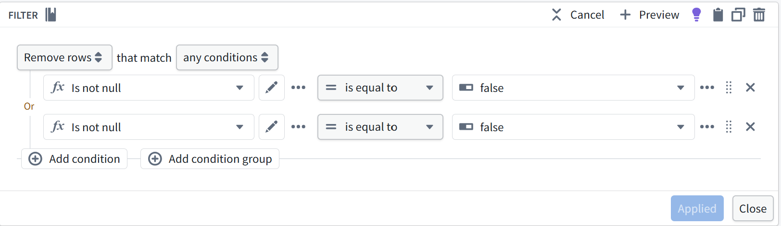
- Add a derived column, claimAgeDays, calculated from the claim's submission date to today's date — you'll use this later when reasoning about claim prioritization.
a. Add a new column
Below your Filter node, open the option to add Timestam Difference transformation. This opens the expression configuration panel.
b. Set the Start field
Click the Start field and select your submissionDate column directly — it's already usable here as a date/timestamp value, so there's no separate conversion step needed.
c. Set the End field
Click the End field, and instead of picking a column, search for and insert the Current timestamp expression.
d. Set the Unit
In the Unit dropdown, select Days.
e. Name the output column
On the right side, where it says claimAgeDays with a New tag — type claimAgeDays into that field. This is what assigns the result of the expression to your new column.
d. Preview, then apply
Click Preview (top right) to confirm it's returning sensible day-count values against your data. Once it looks right, the Applied button becomes active — click it, then Close to return to your pipeline graph.
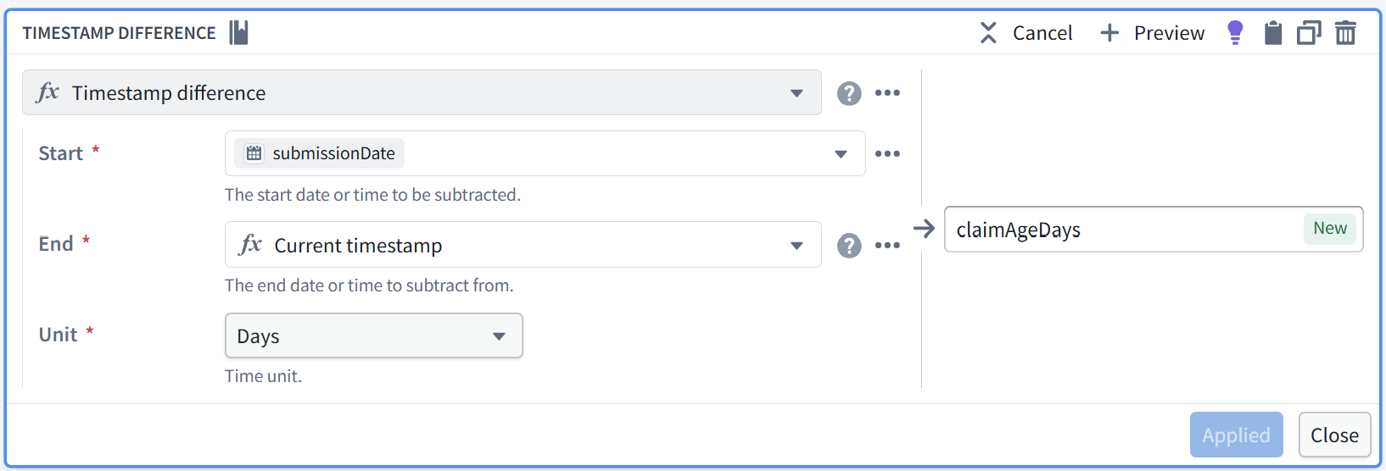
- Add a second derived column, isHighValueClaim, as a boolean: true where claimAmount is greater than 25,000, false otherwise. Use a comparison expression (claimAmount > 25000) and confirm the output column's type is Boolean, not Integer.
a. Open a new column on your transform
On the same transform node where you added claimAgeDays, add another new column (same + Add column action as before).
b. Select the function
In the function dropdown (the ƒx field at the top), search for and select Greater than.
c. Set the Left side
Click the Left field and select claimAmount from your columns — you'll see it tagged with the 123 icon, confirming it's being read as a number.
d. Set the Right side
Click the Right field and enter 25000 directly as a literal value (not a column reference) — it'll show the same 123 numeric tag.
e. Name the output column
On the right-hand side, where it shows isHighValueClaim with a New tag, type isHighValueClaim into that field — same pattern as naming claimAgeDays earlier, this is what assigns the comparison's result to your new column.
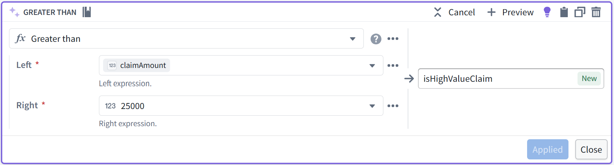
f. Preview to confirm boolean output
Click Preview (top right). You should see isHighValueClaim returning true/false values, not numbers — a Greater than comparison always outputs a boolean, so you don't need a separate step to force the type.
g. Verify the type before moving on
This is the one worth double-checking given Part 7.3's constraint: after applying, check the column's type in your schema panel and confirm it shows as Boolean, not Integer. It should be automatic since Greater than returns a boolean by construction — but confirm it rather than assume it, since this column is what makes the security policy in Part 7.3 possible at all.
h. Apply and close
Click Applied, then Close to return to your pipeline graph. isHighValueClaim now sits alongside claimAgeDays as a second derived column on the same transform node.

Add the Output Dataset
- Select Add next to the Dataset output type in the outputs panel.
- Rename the output to claims_transformed.
- Use updated schema to pull the schema from your transform node automatically.
- Leave the write mode on Default — this is the recommended setting for incremental batch pipelines like this one.

Deploy
- Select Deploy. Wait for the first build to complete — this first run processes the full dataset (a snapshot), which is expected and normal.
- Confirm claims_transformed now exists with 294 rows (300 source claims minus the 6 with an empty policyId), including the assignedAdjusterId column carried through from raw_claims.
Checkpoint — Confirm Before Continuing
claims_transformed exists with 294 rows, and its input (raw_claims) shows the incremental badge.

Part 3 — Configure Schema and Data-Quality Checks
This Part adds guardrails so that bad data fails the pipeline build loudly, instead of flowing silently into your Ontology.

Add an Expectation on Your Output
- Open claims_transformed inside Pipeline Builder. Select the output node.
- Add an expectation requiring claimAmount to be greater than zero.
- Add a second expectation requiring policyId to be non-null (this reinforces the filter from Part 2, as a safety net rather than a duplicate).
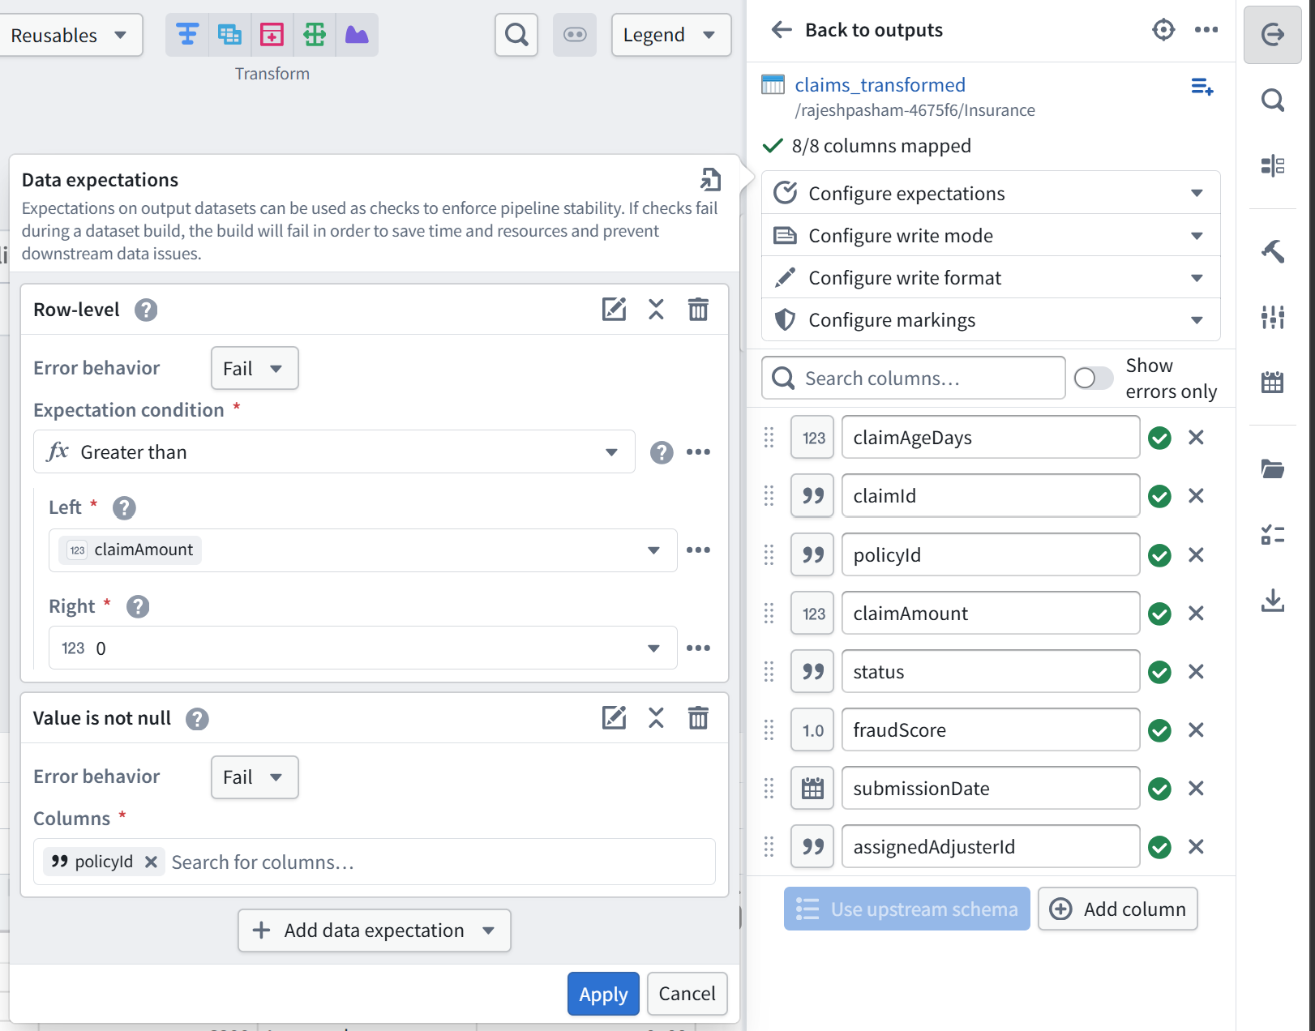
- Save your pipeline configuration.

3.2 Test That the Check Actually Works
An untested data-quality check is not a data-quality check — confirm it actually fails when it should.
  - Temporarily edit your transform to allow the 6 empty-policyId rows through, then re-deploy.
    - Enable Force snapshot on next build option under snapshot settings in deployment settings.
  - Confirm the build fails, and that the failure message references your policyId expectation.
  - Revert your transform back to the correct filter logic, then re-deploy and confirm the build succeeds with 294 rows again.
Checkpoint — Confirm Before Continuing
You have seen the pipeline fail on the empty-policyId rows, and succeed once the filter was restored. If you only ever saw it succeed, your expectation isn't actually being tested.

Part 4 — Implement Branching and Controlled Promotion
Day 1's theory session explained why branching matters conceptually — feature branches, environment branches, why long-lived branches drift. This is where you actually do it for the first time, on the pipeline you just built.

4.1 Create a Feature Branch
- From the top bar of your Pipeline, create a new branch. Name it add-payment-status-flag.
- Confirm you are now working on this branch, not on master — the branch indicator in the top bar should show your branch name.

4.2 Make a Change on the Branch
- On this branch, add a new transform to claims_transformation_pipeline that joins in a hasOpenPayment flag from raw_payments — true if the claim has at least one payment with paymentStatus of Pending, false otherwise. About 63 of your 300 payments are Pending, so expect a meaningful share of claims to come back true.
Step 1 — Bring raw_payments into your pipeline graph
On your add-payment-status-flag branch, use Add datasets to bring raw_payments in as a new source node, separate from your raw_claims branch. It'll sit as its own starting point in the graph.
Step 2 — Flag each individual payment row as Pending or not
Add a new column on raw_payments:
- Transformation: Equals — check paymentStatus equals "Pending"
- Name the output column something like isPending
- This gives you a boolean per payment row, not yet per claim
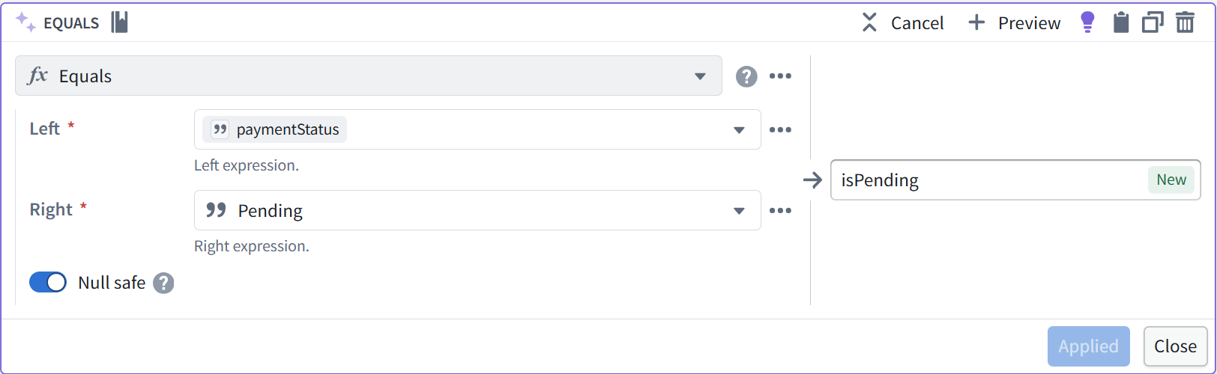
Step 3 — Collapse to one row per claim with an Aggregate step
Add an Aggregate transform downstream of that:
- Group by: claimId
- Aggregation: look for an aggregation function like Any (or Max, if "Any" isn't available in your version) applied to isPending — either will correctly return true if at least one payment row for that claim was Pending
- Name this aggregated output column hasOpenPayment
- The result: one row per claimId, with a single true/false value
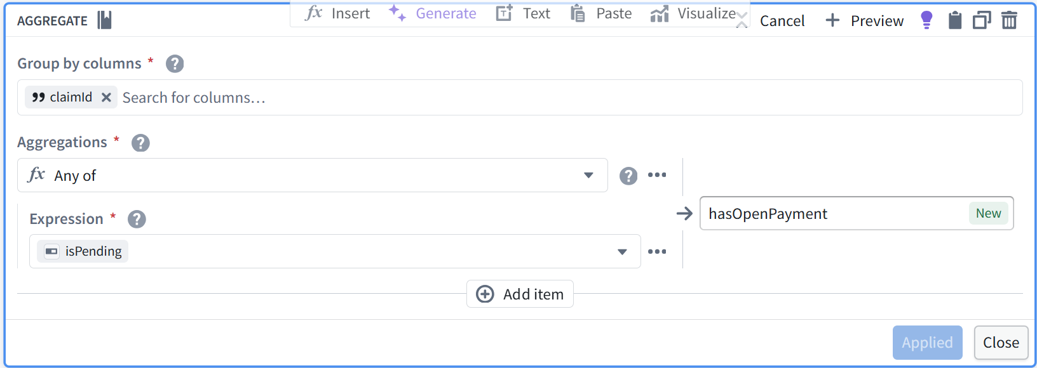
Step 4 — Join that result onto your claims branch
Select both your claims transform node (from Parts 2–3) and this new aggregated payments node, and choose Join:
- Join type: Left join, with claims as the left side — this matters, because you want to keep every claim even if it has zero payments
- Join key: claimId on both sides
- Bring across the hasOpenPayment column from the payments side
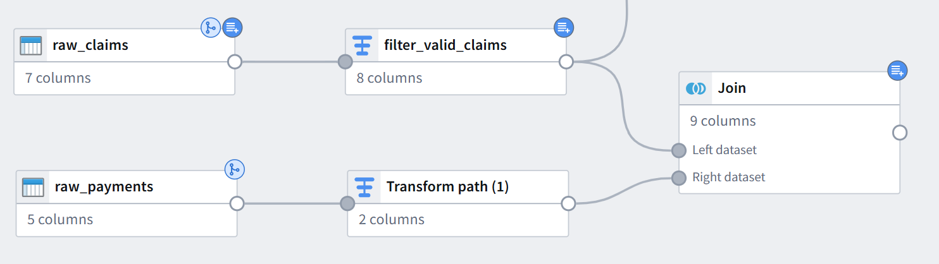

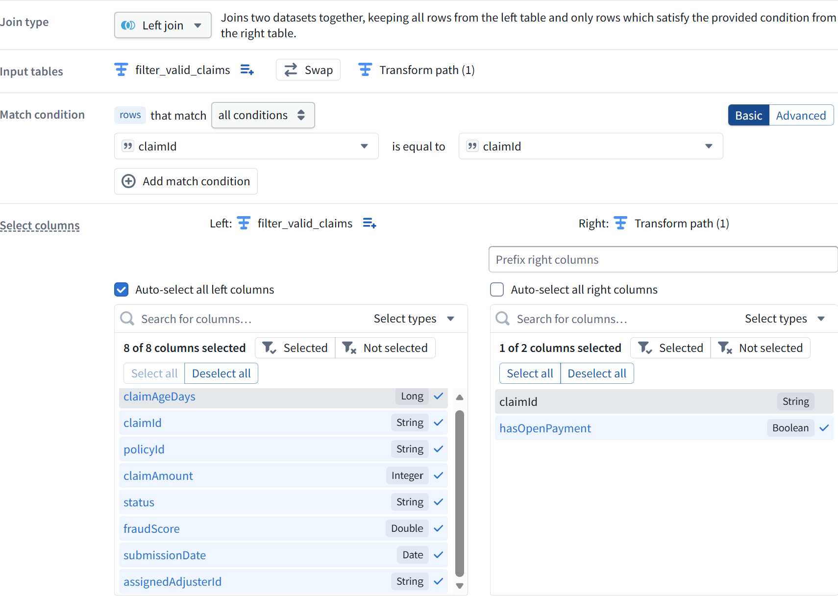
Step 5 — Handle claims with no payments at all
A claim with zero payments won't find a match in the join, so hasOpenPayment will come back null, not false. Add one more column step:
- Use a null-handling transformation (look for First Not null value(coalesce)) that says: if hasOpenPayment is null, use false; otherwise keep the joined value
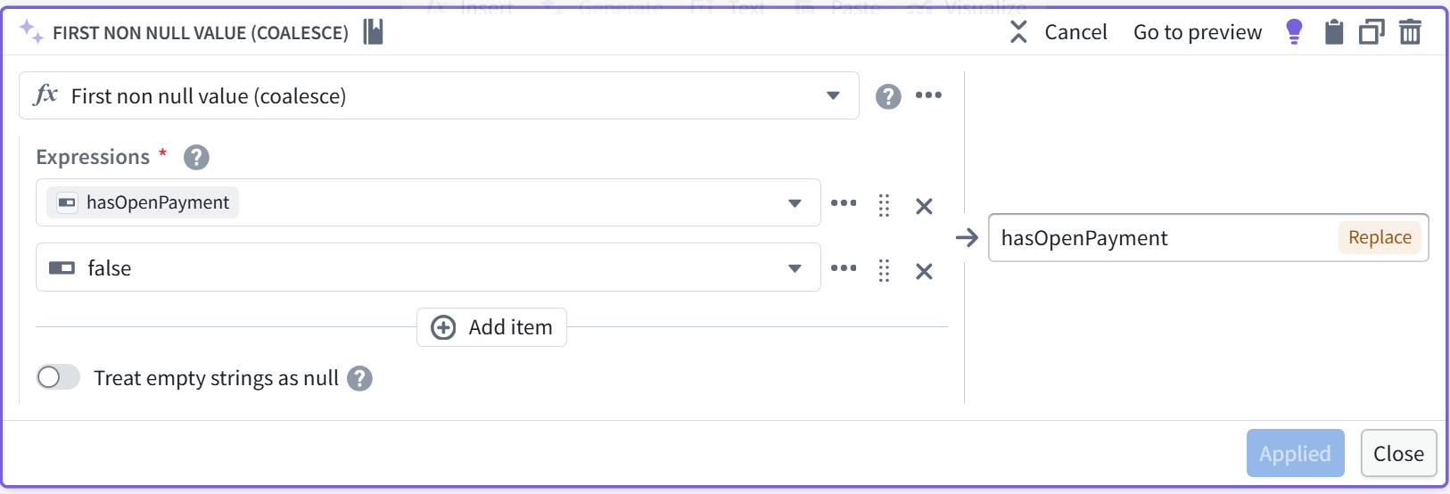
- This is the step most people skip, and it's the one that matters — a null and a false look similar in a preview but behave very differently in Part 7's security policy later
Step 6 — Verify with Preview
Click Preview and spot-check a few rows: pick a claimId you can see has a Pending payment in raw_payments and confirm hasOpenPayment shows true; pick one with only Completed payments and confirm false; pick one with no payment rows at all and confirm it's false, not blank. With 63 of 300 payments Pending, you should see a meaningful — not tiny, not majority — share of claims come back true.
Step 7 — Apply and connect into your main pipeline
Once Preview looks right, click Applied, then wire this joined output into claims_transformation_pipeline so hasOpenPayment flows through to your claims_transformed output alongside claimAgeDays.

- Deploy this change. Confirm it builds successfully on your branch, without affecting the version on master.

4.3 Review, Then Merge
- Review your own change as if you were a second reviewer: does the new column do what its name says?
- Merge your branch back to master.
- Confirm claims_transformed on master now includes the hasOpenPayment column, with a mix of true and false values.
Checkpoint — Confirm Before Continuing
Your pipeline change went through a branch, not a direct edit to master, and you can see the new column on master only after merging.

Part 5 — Create the Seven Ontology Objects
Day 1's theory session explained what Object Types, Properties, and Link Types are conceptually — this is where you build them for the first time. The workflow below is new; you'll repeat the same five steps seven times, once per Object Type, so it will feel familiar by the third or fourth repetition even though it's unfamiliar right now. Work through the objects in the order given further down — later ones depend on earlier ones already existing.

5.1 The Workflow
Step | Action
1 | Ontology Manager → New → Create object type
2 | Select the backing dataset — every Object Type in this lab has one, so you'll always pick an existing dataset here, never generate an empty one
3 | Configure a primary key and a title key
4 | Configure properties (adding any not already in the backing dataset)
5 | Save

5.2 Object Specifications
Create these seven Object Types, in this order. Every one is backed by a real dataset from Part 1 — use the properties listed as a minimum, and add more if you think the model needs them.
Object Type | Primary Key | Key Properties & Backing Data
Policyholder | policyholderId | name, dateOfBirth, contactEmail (PII). Backed by raw_policyholders (300 rows).
Insurance Policy | policyId | policyLimit, coverageType, startDate, endDate. Backed by raw_policies (300 rows).
Claim | claimId | claimAmount, status, fraudScore (sensitive), claimAgeDays, hasOpenPayment, assignedAdjusterId. Backed by claims_transformed from Part 2–4 (294 rows).
Adjuster | adjusterId | name, team, caseloadCount. Backed by raw_adjusters (20 rows).
Claim Document | documentId | documentType, uploadDate, fileReference. Backed by raw_claim_documents (586 rows).
Payment | paymentId | amount (sensitive), paymentDate, paymentStatus. Backed by raw_payments (300 rows).
Investigation | investigationId | openedDate, status, riskLevel. Backed by raw_investigations (60 rows).
Note the order: Adjuster is created before Claim Document and Payment, because Investigation (created last) links to both Claim and Adjuster, and it's easier to wire up a Link Type when both sides already exist.
Checkpoint — Confirm Before Continuing
All seven Object Types are visible in Ontology Manager, each with a valid primary key, each backed by real data, and each showing the expected row count when you preview it — from 20 (Adjuster) up to 586 (Claim Document).

Part 6 — Define Complex Object Relationships
Day 1's theory session covered cardinality reasoning conceptually — get it from what stakeholders or documented requirements actually say, not assumption. Here's how that translates into an actual choice in Ontology Manager, for the first time: object type foreign keys for one-to-one or many-to-one cardinality, object-backed link types for many-to-many or when the relationship itself needs metadata.
Link | Cardinality | Type | FK Column
Policyholder → Insurance Policy | One-to-many | Foreign key | Policy.policyholderId
Insurance Policy → Claim | One-to-many | Foreign key | Claim.policyId
Claim → Claim Document | One-to-many | Foreign key | ClaimDocument.claimId
Claim → Payment | One-to-many | Foreign key | Payment.claimId
Claim → Investigation | One-to-one, optional | Foreign key | Investigation.claimId
Investigation → Adjuster | Many-to-one | Foreign key | Investigation.adjusterId
Claim → Adjuster (assigned) | Many-to-one | Foreign key | Claim.assignedAdjusterId
Creating Each Link Type
- From either Object Type's Overview page, select Create new link type within the link graph.
- Choose Object type foreign keys for every link in the table above, using the FK Column listed.
- Select the foreign key property on the “many” side and the primary key it points to on the “one” side.
- Save, then confirm the link appears on both connected Object Types' Overview pages.

Validate Full Navigability
- In the Claim Object Type, filter for any claim where claimAmount is greater than 25,000 — pick one as your test case for the rest of this lab. Open it and confirm you can navigate to its Insurance Policy, then from there to its Policyholder — two hops, both working.
- From the same Claim, confirm you can navigate to its Payments, its Claim Documents, and its assigned Adjuster. If it's one of the 60 investigated claims, confirm you can also navigate to its Investigation, and from there to the investigating Adjuster.
Checkpoint — Confirm Before Continuing
You can navigate Policyholder → Policy → Claim → Payment / Claim Document / Adjuster / Investigation → Adjuster entirely through the Ontology, without looking at any raw dataset.

Part 7 — Apply RBAC and ABAC Controls
This directly applies Day 2's RBAC and ABAC content to the Ontology you just built.

7.1 RBAC — Confirm Your Role
- Open your Project's sharing settings. Confirm your own Role (you should be Owner, since you created this Project and everything in it).
- You won't be able to test RBAC across multiple people in an individual account — instead, write down what Role you would assign to each Day 2 persona (Adjuster, Auditor, New Hire, Fraud Analyst) if this were a shared Project. This is a design exercise: bring it to Day 4 or Day 5 for review.
Persona | Role You'd Assign, and Why
Adjuster
Auditor
New Hire
Fraud Analyst

7.2 ABAC — Create a Marking
- Navigate to Foundry Settings, then the Markings section.
- Create a new Marking named High-Value Claim.
Important: creating a Marking automatically grants you Manage permissions on it — the ability to administer who is eligible. It does not automatically make you eligible yourself. That distinction is exactly what Part 8 tests.

7.3 Apply Object-Level Security to Claim
- Open the Claim Object Type in Ontology Manager.
- Configure an object security policy: objects where isHighValueClaim is true require the High-Value Claim Marking to view. This applies to the 34 high-value claims in your dataset.
- Save. This is row-level security — it controls whether the Claim object is visible at all.

7.4 Apply Property-Level Security
- On the same Claim Object Type, configure a property security policy on fraudScore, requiring the same High-Value Claim Marking.
- Confirm you cannot select the object's primary key (claimId) when configuring this — property security policies apply to any property except the primary key, by design.
Checkpoint — Confirm Before Continuing
Claim has both an object security policy (row-level, based on claimAmount) and a property security policy (column-level, on fraudScore), both referencing the High-Value Claim Marking. You have Manage permissions on the Marking, but have not yet added yourself as eligible.

Part 8 — Test Restricted Access, Solo Method
This Part does not require a second account. It uses the distinction from Part 7.2 — managing a Marking is not the same as being eligible for it — to run a genuine before/after access test using only your own identity, against the test claim you picked in Part 6.

8.1 Before You Are Eligible
- Without adding yourself to the High-Value Claim Marking's eligible members, attempt to view your test claim from Part 6 (one of the 34 with claimAmount above 25,000).
- Confirm you cannot see the object, or cannot see it at all in a list view of Claim — this is object-level security working as configured, even though you administer the Marking.
- If your environment has a Check access or similar simulation panel, use it to inspect your own effective access to this claim, and confirm it names the High-Value Claim Marking as the blocking factor.

8.2 After You Are Eligible
- From Foundry Settings → Markings → High-Value Claim, add yourself to the Marking's eligible members (this is a separate action from the Manage permissions you already have).
- Refresh and re-attempt to view your test claim. Confirm you can now see it, including its fraudScore value.
- Pick any claim with claimAmount well under 25,000 and confirm you could see this one throughout, with or without the Marking — object security only applies above the threshold.
Record Your Results
Test |  | Observed Result
Your high-value test claim, before adding yourself as eligible
Check access panel result, before eligibility (if available)
Your high-value test claim, after adding yourself as eligible
A low-value claim, for comparison
Checkpoint — Confirm Before Continuing
You have direct evidence — not just configuration — that access was denied before you were eligible for the Marking and allowed after, using only your own account. If your test claim was visible even before Step 8.2, revisit 7.3–7.4 before continuing.

Part 9 — Review Lineage and Downstream Dependencies
- Open Data Lineage on your claims_transformed dataset.
- Trace backward: confirm you can see raw_claims as its source, and (from Part 4) raw_payments feeding the hasOpenPayment column.
- Trace forward: confirm you can see the Claim Object Type listed as a downstream consumer of claims_transformed.
- Write one sentence on what would break, and for whom, if raw_claims changed its schema without warning.

Checkpoint — Confirm Before Continuing
You can explain, using the lineage graph rather than memory, exactly what feeds your Ontology and what depends on it.

Full Validation Checklist
- ☐ All seven reference datasets exist with the expected row counts, loaded via Method A or Method B
- ☐ claims_transformation_pipeline runs incrementally, with a passing data-quality expectation
- ☐ You have seen the expectation fail on the empty-policyId rows and pass once corrected
- ☐ A pipeline change was made on a branch and merged, not edited directly on master
- ☐ All seven Object Types exist, every one backed by real data, with valid primary keys
- ☐ All seven relationships are navigable end to end through the Ontology
- ☐ A High-Value Claim Marking exists, with object- and property-level security policies on Claim
- ☐ Restricted access was tested solo, before and after adding yourself as an eligible member
- ☐ Lineage for claims_transformed has been traced backward and forward

Reflection Questions
- Part 7.2 pointed out that managing a Marking and being eligible for it are different things. Where else in an enterprise setting would that distinction matter — who should administer access without necessarily having it themselves?
- If you had skipped Part 3's data-quality check, where downstream would a claim's missing policyId have surfaced instead — and would it have been obvious what caused it?
- Now that fraudScore is protected by a Marking, what would you need to confirm before letting a Week 2 Copilot read the Claim object type?

If You Run Out of Time
Complete Parts 1–6 (the Ontology and pipeline itself) as the minimum before Day 4 — Parts 7–9 (security and lineage) can be finished as the first thing you do on Day 4 if needed, since Day 4's mentoring session will review your governance configuration anyway. Note in your validation checklist exactly which Parts remain, so Day 4's session can pick up precisely where you left off.

Troubleshooting
Symptom | Likely Cause & Fix
CSV upload succeeds but every column shows as text | You haven't applied a schema yet — select Apply a schema, then Edit schema to correct any misread types
Pipeline build fails immediately with no clear error | Check that every input node is connected to a transform, and every transform is connected to an output — an orphaned node is the most common cause
Incremental badge doesn't appear on downstream nodes | Confirm the upstream input is actually marked Incremental, not just added to the graph — this is a separate toggle from adding the data
Expectation doesn't fail even with the empty-policyId rows included | Confirm the expectation is attached to the output node, not a transform node, and that you redeployed after adding it
Can't select a primary key when creating an Object Type | The backing dataset likely has duplicate values in your intended key column — check for duplicates upstream before retrying
Link Type won't save | Cardinality mismatch — re-check whether the relationship is really one-to-many both ways, or if one side needs to be optional (this applies to Claim → Investigation specifically, since only 60 of your 300 claims have one)
Property security policy option is missing | Confirm you've already created and saved an object security policy on that Object Type first — property policies are configured on top of an existing object policy
You can see your test claim even before Part 8.2 | You may have added yourself as eligible while creating the Marking in 7.2 — check the Marking's member list and remove yourself, then redo the before/after test correctly
Method B script runs but row counts don't match | Confirm random.seed(42) is set before any random calls, and that you haven't reordered the generation blocks — the sequence of random calls affects the output, including for the adjusters/investigations/claim_documents extension
Lineage graph looks empty or incomplete | Confirm you're viewing lineage on the dataset itself (claims_transformed), not on the Object Type — try both views if one seems incomplete

